DAYS 20-21
GeoIP Blocking and Firewall Rules
// 01 OVERVIEW & SCOPE

Days 20 and 21 shift from detection to a specific prevention technique: blocking inbound traffic based on the geographic origin of the source IP. If an organisation has no legitimate users, customers, or partners in a given country, traffic from that country's IP ranges carries essentially no cost to reject outright. This reduces attack surface, particularly against high-volume, low-sophistication scanning and automated attack traffic, which makes up a large share of real-world internet noise.
The implementation uses ipset combined with iptables rather than a live GeoIP lookup module. ipset loads an entire country's CIDR ranges — which can number in the thousands — into a single kernel-level hash structure, so a single iptables rule can match against the whole set in one efficient lookup rather than iterating thousands of individual rules per packet.
A second, unrelated technique — domain blocking via /etc/hosts — was configured to demonstrate host-level DNS redirection as a lighter-weight, less robust alternative to true packet filtering.

$ Deliverables in This Report
- ipset and iptables rules for two to three blocked countries
- Verification of the block mechanism using a controlled stand-in IP
- /etc/hosts domain redirection and confirmation of failed access
- Assessment of Wazuh visibility into blocked traffic, and what is required to close that gap

// 02 IPSET & IPTABLES GEOIP BLOCKING

$ Package Installation
iptables and ipset were installed on the Kali VM. The xt_geoip kernel module (via xtables-addons) was evaluated but not required — the ipset approach matches statically downloaded country CIDR ranges rather than performing live geolocation, which is simpler and does not depend on that module.
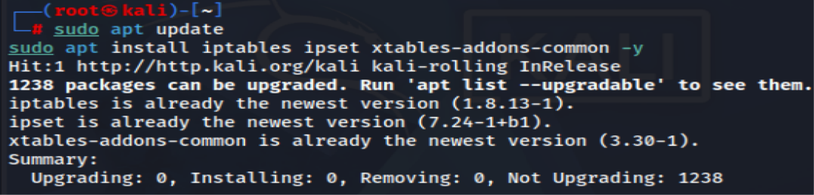

$ Downloading Country IP Blocklists
CIDR-format IP range lists were downloaded from ipdeny.com for three countries selected as having no legitimate traffic relevance to this lab environment: China (cn), Russia (ru), and North Korea (kp).
Each file contains one CIDR range per line — the raw list of allocated address blocks for that country, e.g. 1.0.1.0/24.
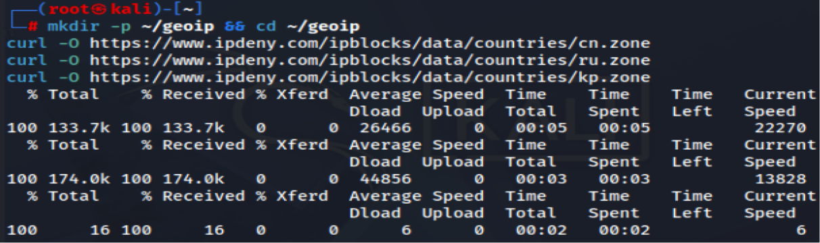
$ Creating and Populating ipsets
One hash:net ipset was created per country, then populated by reading each line of the corresponding downloaded file.
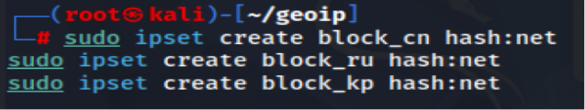
ipset populated from ipdeny.com country blocklist

// 03 RULE ENFORCEMENT & VERIFICATION

$ iptables Rules
A single DROP rule was added to the INPUT chain per ipset. DROP was chosen over REJECT deliberately: DROP silently discards the packet with no response, giving an external scanner no confirmation that a firewall decision was even made, whereas REJECT would send back an explicit refusal that reveals the block.
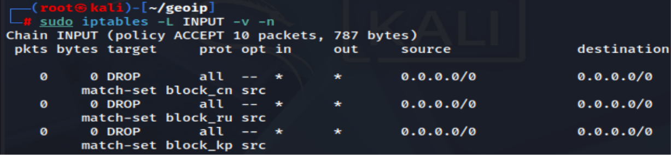
INPUT chain — GeoIP DROP rules active

$ Verifying the Block
Directly sourcing traffic from a real foreign IP was not practical inside this lab topology, so the blocking mechanism was verified using a controlled stand-in: the Ubuntu Server's known IP was temporarily added to a test ipset and blocked, confirming connectivity failure, then the rule was removed and connectivity confirmed restored.
This confirms the ipset-plus-iptables mechanism correctly drops traffic matching a loaded address, which generalises directly to the real country ranges — the DROP logic has no awareness of what the address represents, only whether it matches an entry in the referenced set.
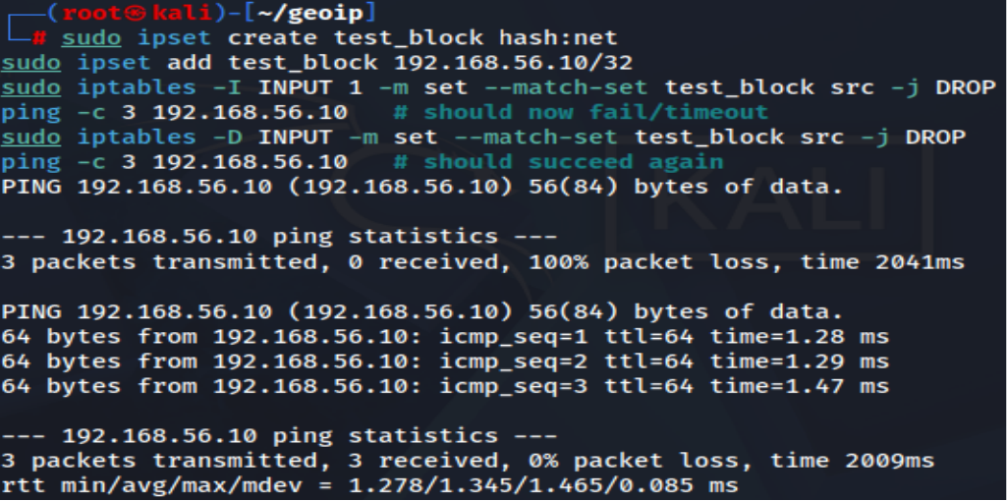
Verification via controlled stand-in IP, since real foreign-sourced traffic was not obtainable in-lab

// 04 UFW / /ETC/HOSTS DOMAIN BLOCKING

A separate, lighter-weight technique was configured for comparison: redirecting specific domains to localhost via /etc/hosts. This is explicitly not a true firewall block — it is a DNS-level workaround that only affects clients trusting the local hosts file, unlike iptables which filters at the packet level regardless of what any application believes about DNS.
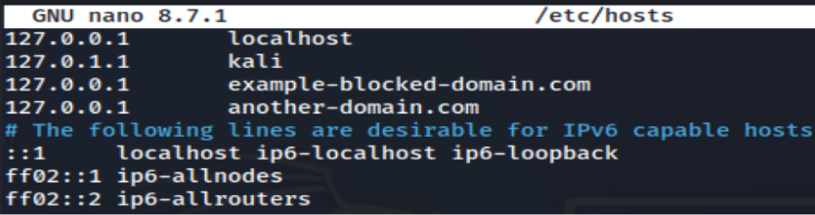
After saving, requests to the redirected domains were tested and confirmed to fail, since the domain now resolves to localhost where nothing is listening on the relevant port.
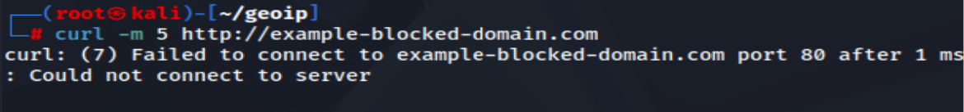
Domain access blocked via local hosts-file redirection
// 05 WAZUH VISIBILITY INTO BLOCKED TRAFFIC

Wazuh does not monitor iptables drop activity out of the box — there is no default localfile or decoder watching kernel firewall logs. To make blocked traffic visible, iptables must be explicitly configured to log matching packets, and Wazuh must then be pointed at that log source.
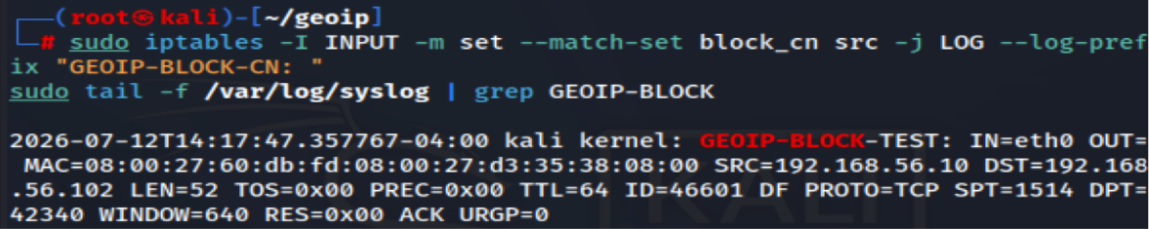
Without this additional LOG rule and a corresponding Wazuh localfile entry monitoring syslog (or kern.log) with an appropriate decoder, GeoIP drops occur silently at the kernel level and generate zero dashboard activity. This is a genuine visibility gap worth flagging: a defensive control can be functioning correctly while remaining completely invisible to the monitoring stack unless explicitly wired together.

$ What Closing This Gap Would Require
- An iptables LOG rule preceding each DROP rule, with a distinct log prefix per country for easy identification
- A <localfile> block on the Kali agent monitoring /var/log/syslog (or /var/log/kern.log depending on syslog configuration)
- A custom Wazuh decoder/rule pair to parse the GEOIP-BLOCK log prefix into a structured, searchable alert, similar to how the Suricata integration in Days 18-19 required an explicit localfile/decoder pairing rather than working automatically

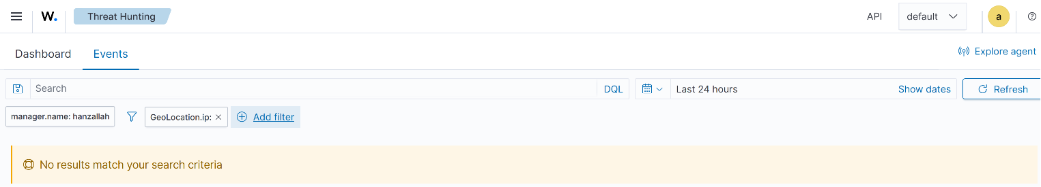

// 06 FIREWALL RULESET REFERENCE

Complete reference for reproducing this setup.
$ Ipsets
- block_cn — hash:net — populated from cn.zone (China) — https://www.ipdeny.com/ipblocks/data/countries/cn.zone
- block_ru — hash:net — populated from ru.zone (Russia) — https://www.ipdeny.com/ipblocks/data/countries/ru.zone
- block_kp — hash:net — populated from kp.zone (North Korea) — https://www.ipdeny.com/ipblocks/data/countries/kp.zone
$ iptables Rules
- INPUT -m set --match-set block_cn src -j DROP — drops all inbound traffic sourced from any address in the China ipset
- INPUT -m set --match-set block_ru src -j DROP — drops all inbound traffic sourced from any address in the Russia ipset
- INPUT -m set --match-set block_kp src -j DROP — drops all inbound traffic sourced from any address in the North Korea ipset
$ Verification Method
Confirmed via controlled stand-in IP (Ubuntu Server, 192.168.56.10) temporarily added to a test ipset and blocked/unblocked, since sourcing genuine traffic from the target countries was not feasible in this lab's network topology.

